
Touchstones Project
Netcards

Remembrance Netcards with Text

Arches HRJ
Arctic HRJ
Art HRJ
Calendar HRJ

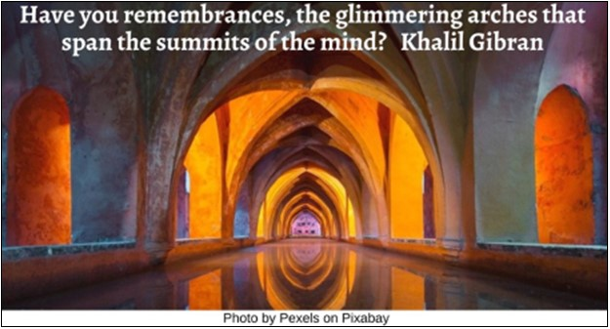

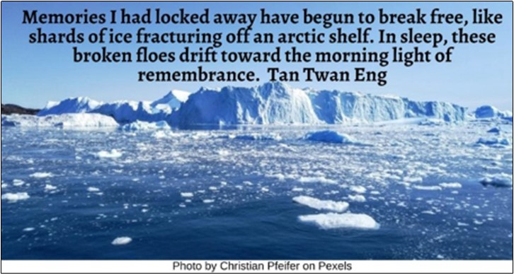

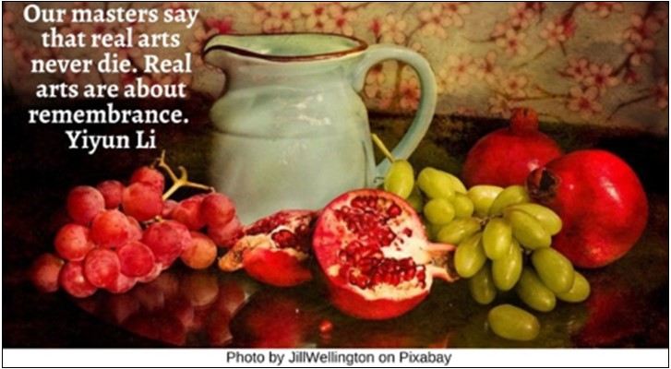

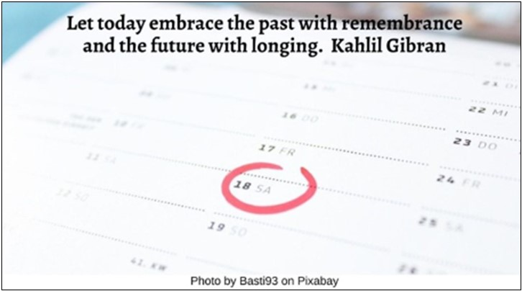

Child HRJ
Childhood Story HRJ
Clock HRJ
Crumbs HRJ

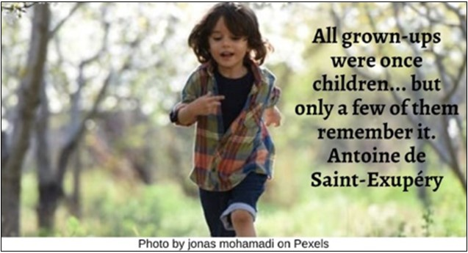

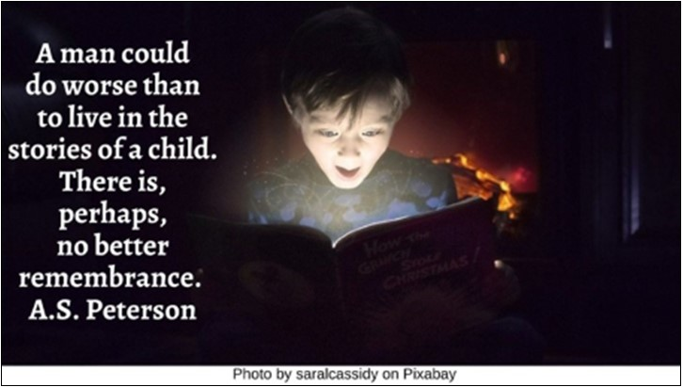

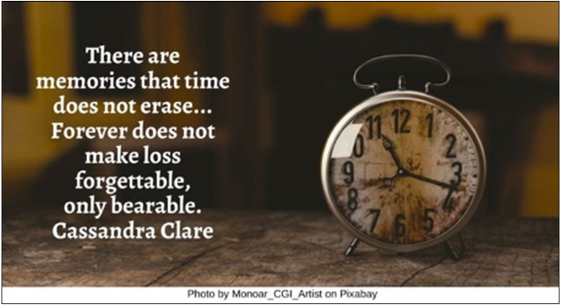

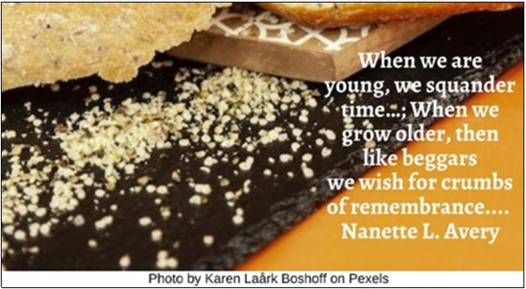

Dawn HRJ
Diary HRJ
Dried Flower HRJ
Fire HRJ

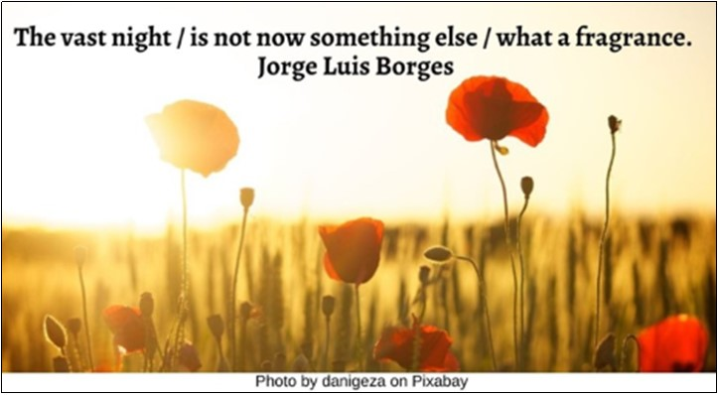

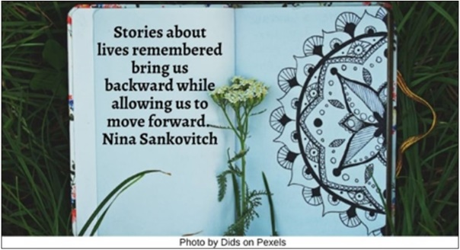

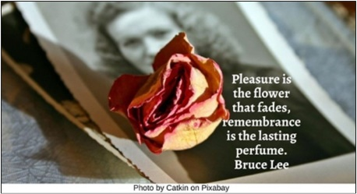

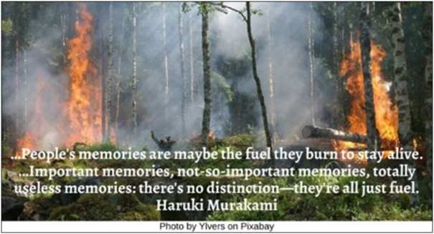

Flower HRJ
Food Bank HRJ
Gandhi HRJ
Grave HRJ

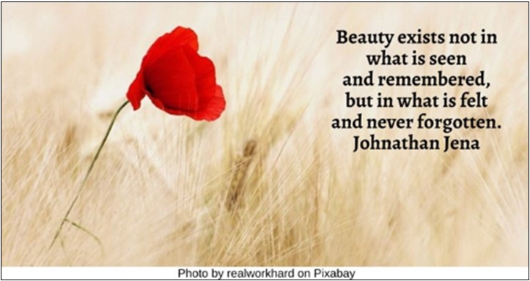

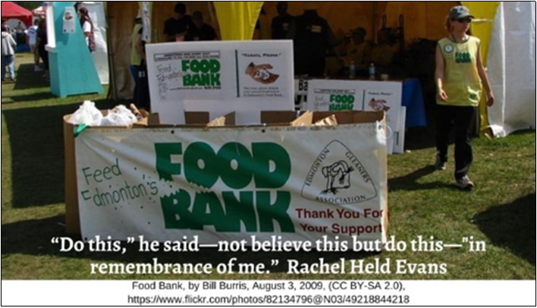

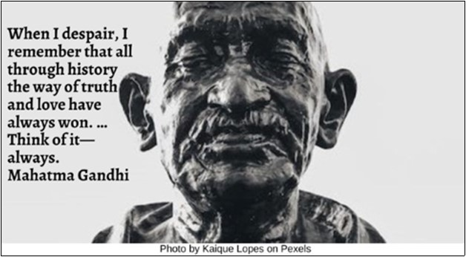

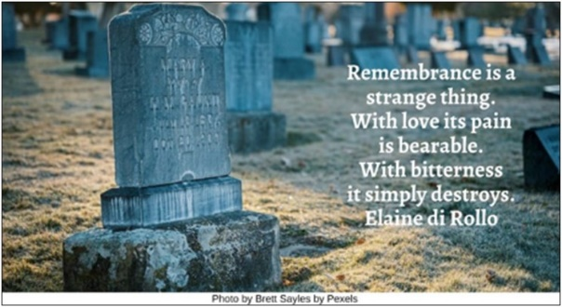

Heart HRJ
History HRJ
Love HRJ
Matin Luther King, Jr. HRJ

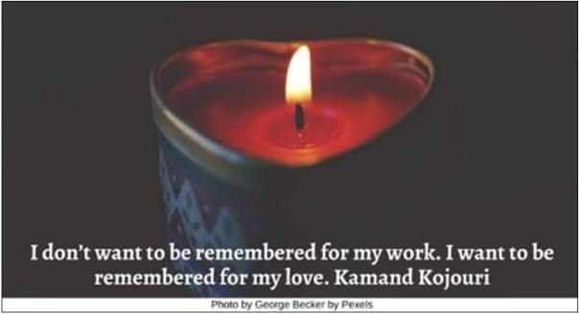

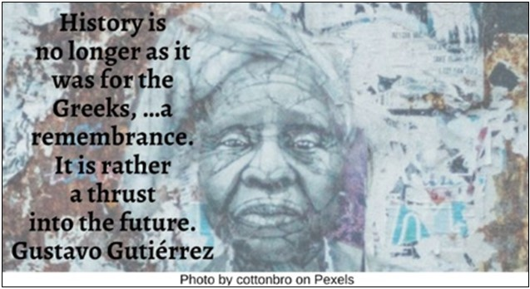



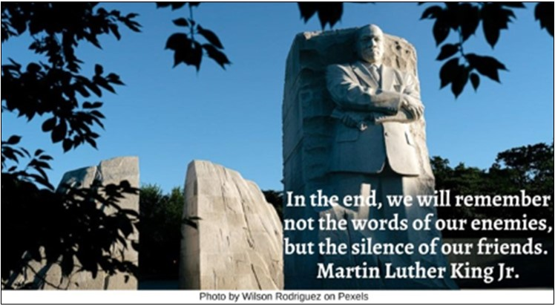

Mirror HRJ
Old Couple HRJ
Parched Evening HRJ
Photograph Album HRJ

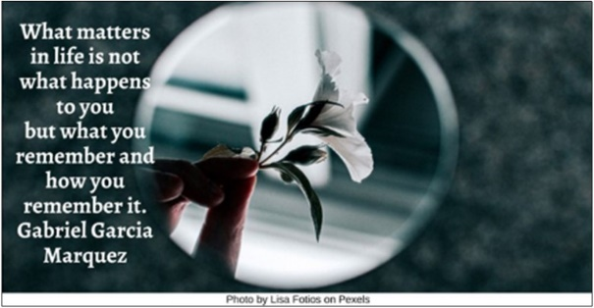

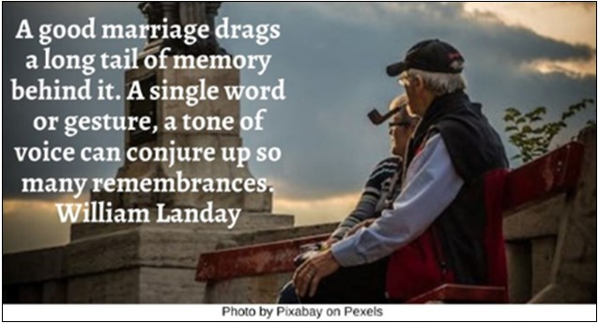

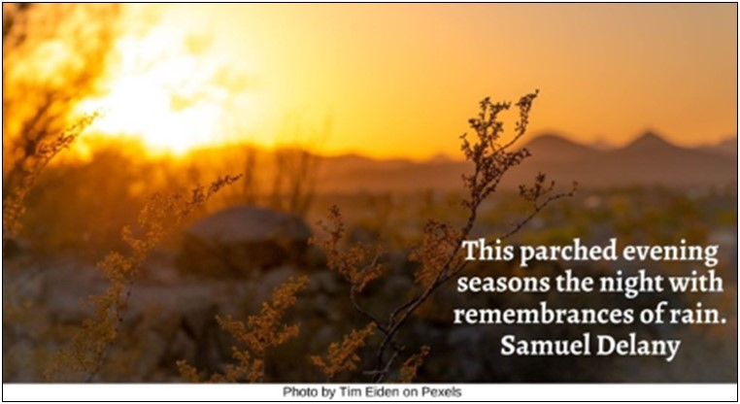

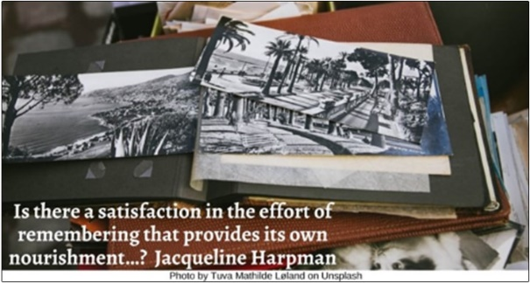

Pyramids HRJ
Remember HRJ
Snow Melt HRJ
Sunset HRJ

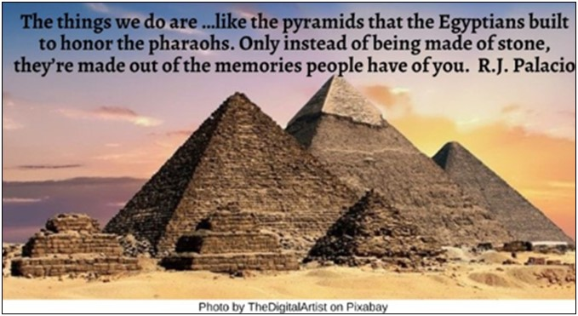

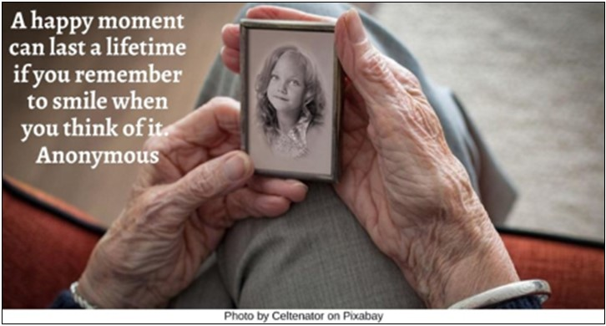

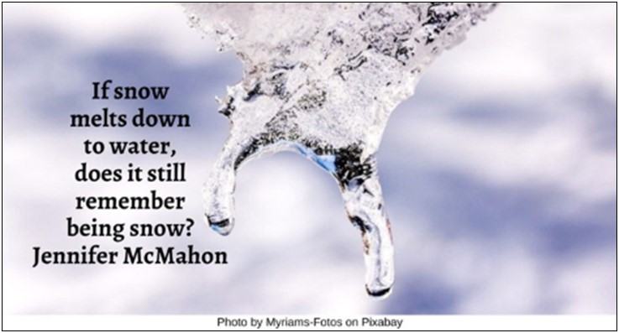

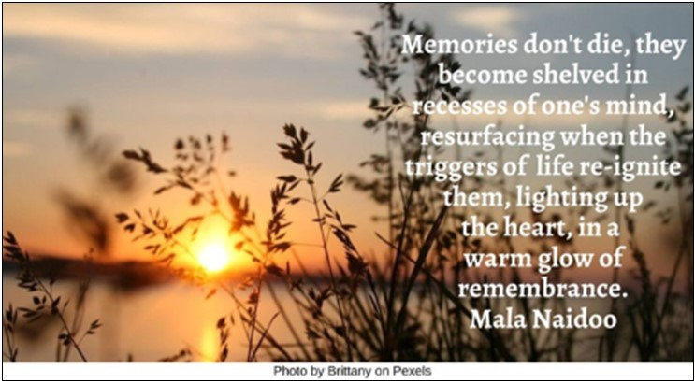

Thinking HRJ
Universe HRJ
Writing HRJ

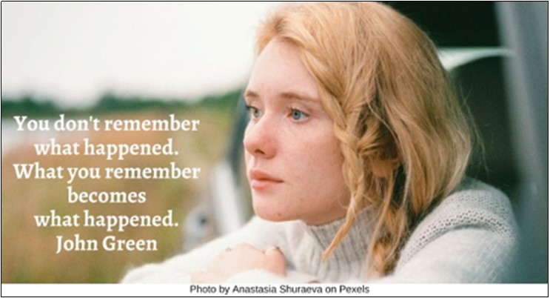

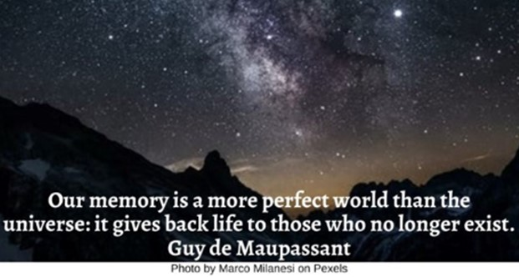

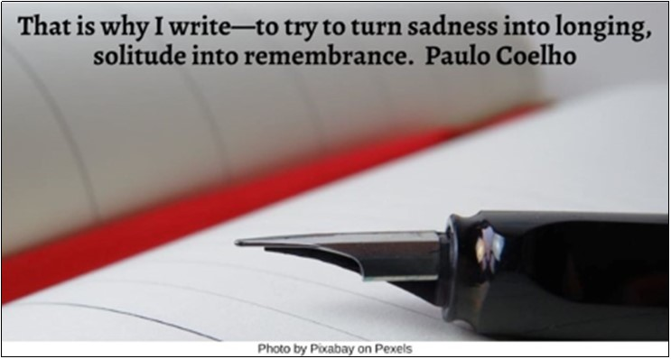

Text of Quotes
Arches HRJ
Have you remembrances, the glimmering arches that span the summits of the mind? Khalil Gibran

Arctic HRJ
Memories I had locked away have begun to break free, like shards of ice fracturing off an arctic shelf. In sleep, these broken floes drift toward the morning light of remembrance. Tan Twan Eng

Art HRJ
Our masters say that real arts never die. Real arts are about remembrance. Yiyun Li

Calendar HRJ
Let today embrace the past with remembrance and the future with longing. Kahlil Gibran

Child HRJ
All grown-ups were once children... but only few of them remember it. Antoine de Saint-Exupéry

Childhood Story HRJ
A man could do worse than to live in the stories of a child. There is, perhaps, no better remembrance. A.S. Peterson

Clock HRJ
There are memories that time does not erase... Forever does not make loss forgettable, only bearable. Cassandra Clare

Crumbs HRJ
When we are young, we squander time as though it were unlimited; When we grow older, then like beggars we wish for crumbs of remembrance.... Nanette L. Avery

Dawn HRJ
The vast night Is not now something else
what a fragrance. Jorge Luis Borges
Diary HRJ
Stories about lives remembered bring us backward while allowing us to move forward. Nina Sankovitch

Dried Flower HRJ
Pleasure is the flower that fades, remembrance is the lasting perfume. Bruce Lee

Fire HRJ
…People's memories are maybe the fuel they burn to stay alive. …Important memories, not-so-important memories, totally useless memories: there's no distinction—they're all just fuel. Haruki Murakami

Flower HRJ
Beauty exists not in what is seen and remembered, but in what is felt and never forgotten. Johnathan Jena

Food Bank HRJ
“Do this,” he said—not believe this but do this—"in remembrance of me.” Rachel Held Evans

Gandhi HRJ
When I despair, I remember that all through history the way of truth and love have always won. …Think of it--always. Mahatma Gandhi

Grave HRJ
Remembrance is a strange thing. With love its pain is bearable. With bitterness it simply destroys. Elaine di Rollo

Heart HRJ
I don’t want to be remembered for my work. I want to be remembered for my love. Kamand Kojouri

History HRJ
History is no longer as it was for the Greeks, …a remembrance. It is rather a thrust into the future. Gustavo Gutiérrez

Love HRJ
After you are gone, people may forget most of what you have said and done. But they will remember that you loved them. Steve Goodier

Martin Luther King Jr HRJ
In the end, we will remember not the words of our enemies, but the silence of our friends. Martin Luther King Jr.

Mirror HRJ
What matters in life is not what happens to you but what you remember and how you remember it. Gabriel Garcia Marquez

Old Couple HRJ
A good marriage drags a long tail of memory behind it. A single word or gesture, a tone of voice can conjure up so many remembrances. William Landay

Parched Evening HRJ
This parched evening seasons the night with remembrances of rain. Samuel R. Delany

Photograph Album HRJ
Is there a satisfaction in the effort of remembering that provides its own nourishment…? Jacqueline Harpman

Pyramids HRJ
The things we do are …like the pyramids that the Egyptians built to honor the pharaohs. Only instead of being made of stone, they're made out of the memories people have of you. R.J. Palacio

Remember HRJ
A happy moment can last a lifetime if you remember to smile when you think of it. Anonymous

Snow Melt HRJ
If snow melts down to water, does it still remember being snow? Jennifer McMahon

Sunset HRJ
Memories don't die, they become shelved in recesses of one's mind, resurfacing when the triggers of life re-ignite them, lighting up the heart, in a warm glow of remembrance. Mala Naidoo

Thinking HRJ
You don't remember what happened. What you remember becomes what happened. John Green

Universe HRJ
Our memory is a more perfect world than the universe: it gives back life to those who no longer exist. Guy de Maupassant

Writing HRJ
That is why I write—to try to turn sadness into longing, solitude into remembrance. Paulo Coelho

